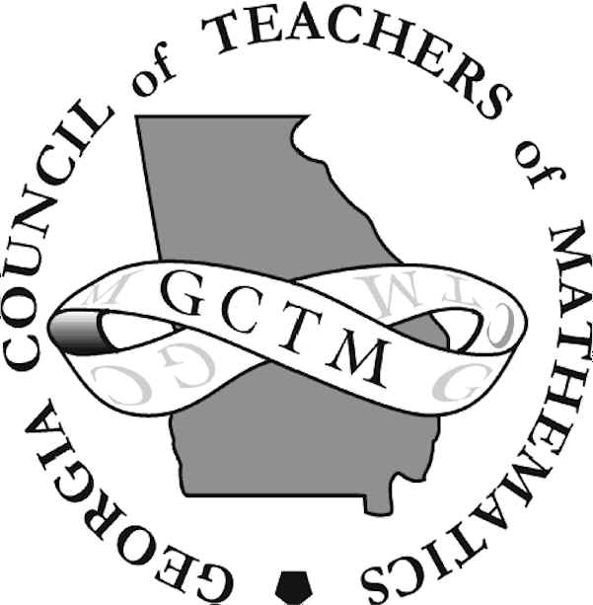GCTM
Middle School Math Tournament
Information
April 18, 2020

It will be held at Tattnall Square Academy,
111 Trojan Trail, Macon, GA 31210.
(Please do not mail your registration form or your registration fee to this address. Email the registration form to angeliqueallen105@gmail.com and the registration fee and/or questions will be collected on-site the day of the tournament.)

Schedule

9:15 – 9:50 Registration
9:30 Game Activity
10:00 – 10:50 Written Test
11:00 – 11:40 Individual Ciphering
11:40 Pizza Party (Free)
12:00 – 12:20 Team Round
12:45 – 1:00 Power Question
1:05 – 1:30 Fright’ning Light’ning
1:30 Awards

Description of Events

Written Test: 30 questions, 45 minutes, done individually, no calculators (5 point each, no penalty for guessing = 150 points * Top 4 team members = 600 maximum).

Individual Ciphering: 10 questions, done in 1 and 2 minute time intervals, no calculators (10 points & 5 points per question = 100 points * Top 4 team members = 400 maximum).

Team Round**: 12 unrelated problems worked by entire 4 member team in 20 minutes (20 points per question = 240 maximum. There are no additional points for completing problems early).

Power Question**(Modeling): 1 multi-part question worked by entire 4 member team, done in 2, 4, 6, 8, and 10 minute time intervals (worth 100-80-60-40-20 points).

**One calculator per pair of students, non-symbolic manipulator (TI-84 and below) for pair ciphering and power question.

Fright’ning Light’ning Round: each student will answer one round of the oral relay. Time limit: a frightening 30 seconds. (Worth sweet treats).

One team of four students is permitted per school.
Only one calculator will be needed for each pair of students (2 per team).
This is a FUN tournament! Your students are certain to enjoy the day.

APPLICATION
GCTM MIDDLE SCHOOL
MATH TOURNAMENT

SATURDAY, APRIL 18, 2020
It will be held at Tattnall Square Academy,
111 Trojan Trail, Macon, GA 31210.
(Please do not mail your registration form or your registration fee to this address. Email the registration form to angeliqueallen105@gmail.com and the registration fee and/or questions will be collected on-site the day of the tournament.)

Non-GCTM member registration:
5 multiple-choice questions and $10 or $20 (To be paid on Saturday at the check-in table)
GCTM member registration:
5 multiple-choice questions or $10 (To be paid on Saturday at the check-in table)

School Name: Click here to enter text.

School Address: Click here to enter text.

School Phone: Click here to enter text.

Fax: Click here to enter text.

Sponsor’s Name: Click here to enter text.

Sponsor’s Address: Click here to enter text.

Sponsor’s e-mail: Click here to enter text.

Sponsor’s Cell Phone: Click here to enter text.
*(This information is so we may reach you should something happen that morning.)

Is Sponsor a member of GCTM? Choose an item.

