March 2021
GCTM would like to sincerely thank Dr. Lya Snell, the GaDOE Mathematics Program Manager, for providing an informative and enlightening Roundtable session on March 30th, 2021. Through this dialogue, members were invited to ask questions and give feedback about the new proposed mathematics standards. Thank you, Lya, for the opportunity to learn more and have our questions answered! We look forward to having you as our Keynote speaker this year at GMC!
Click here to see a full video of this presentation. Use passcode F#2FV@ws .

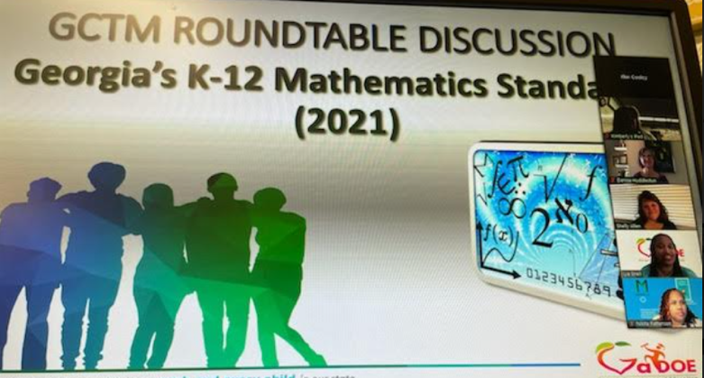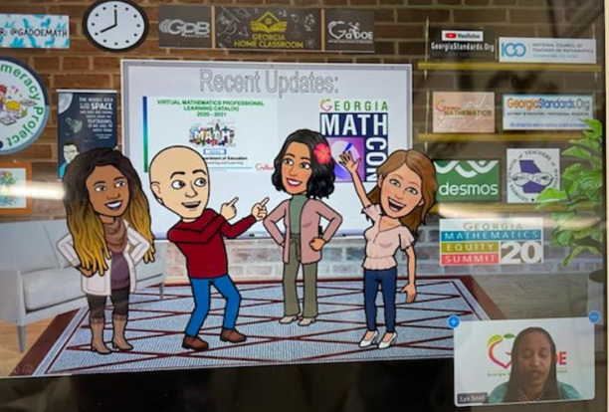

GCTM continues to advocate for math teachers through the state, and our voice is being heard. We were contacted to contribute to the article below on the development of the standards and how it impacts our teachers and state. Click on the article below for more information.

