GCTM Roundtable – January 4th

The second GCTM Roundtable was held on January 4th. Our guest was Mike Dudgeon, Policy Director for the Lieutenant Governor. As a former state representative and school board member, Mr. Dudgeon shared that he is an advocate for educators but especially mathematics teachers because of his experience as an engineering major at Georgia Tech.

Here are a few highlights from the conversation:

Mr. Dudgeon shared that one of the priorities of the Lieutenant Governor has been to advance Georgia so that it becomes the technology capital of the East Coast. He explained that a new public-private partnership has been established to support these efforts - Partnership for Inclusive Innovation.

Through the work of multiple agencies and other partnerships, the expansion of broadband technology throughout Georgia has been identified as a need specifically to support education efforts. He shared that the federal mapping of areas with access to broadband was actually not quite as accurate as the newest mapping that has been completed at the state level by the Georgia Broadband Deployment Initiative (GBDI). 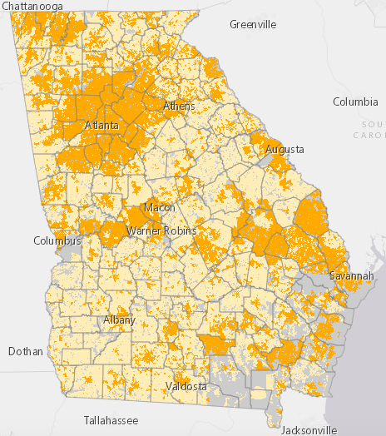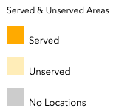

As part of this work, Governor Kemp recently announced that Georgia will allocate $29.3 million to provide school districts with more options to connect students to the internet this academic year by ensuring all of Georgia's 2,300 schools have broadband signal extenders from school buildings, and expanding learning environments to support on-campus, socially distanced learning. Options may also be available for transmitting mobile WiFi signals to students who live in multi-family housing.

https://broadband.georgia.gov/fcc-vs-gbdi-broadband-comparison

Standards Update
Mr. Dudgeon said that he had reviewed the updated standards and was particularly interested in the statistics and probability strand that has been updated K-12 and then also within the Algebra II course. He asked for feedback from those on the call and multiple members who served on the standards review teams were able to provide reflection on their own experience on the revision team. A few participants also shared their thoughts on the need for the inclusion of a stronger focus on statistics throughout the newly revised K-12 math curriculum. Members shared that professional learning will be a critical need as we move forward with the planned implementation of the new standards. Mr. Dudgeon took note of the needs that were shared and possible collaboration opportunities with the GCTM Summer Academies and the annual GCTM Conference.

Final thoughts…
Mr. Dudgeon challenged GCTM to share our ideas about how we envision student assessment and CCRPI as we move through the pandemic and beyond. If you would like to share your ideas, please complete the following form: https://forms.gle/9hjqmYRoeMZSidtQ6

Hope you will join us for the next GCTM Roundtable session. We anticipate the session will be held during the first break in the 2021 legislative session about mid-January. More information will be sent out to the GCTM membership through email with the registration link and an opportunity to share a topic or question you would like to have discussed.

