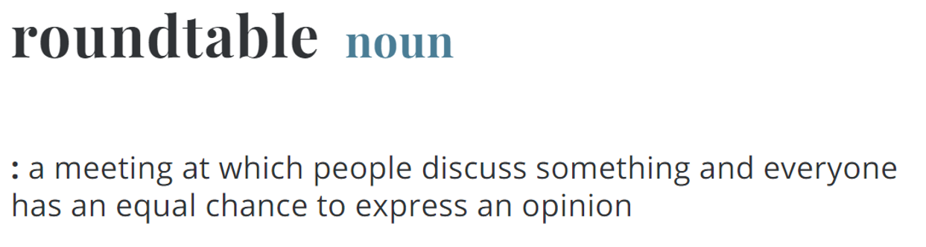
from Merriam-Webster (2021)

Dr. Lya Snell was the featured guest during the GCTM August Roundtable. Dr. Snell joined the group to share the newest updates to the NEW GEORGIA MATHEMATICS STANDARDS. She was actually a repeat guest! At our March GCTM Roundtable, Dr. Snell joined us to introduce the NEW GEORGIA MATHEMATICS STANDARDS and invited members to provide feedback and commentary. At the most recent August Roundtable, Dr. Snell was able to share with everyone the updates that have been made based on public commentary since March. She shared that a Citizens Review Committee composed of students, parents, business and community leaders, and Georgia citizens, along with an Academic Review Committee composed of post secondary partners, child development experts, and business leaders, provided initial feedback and reviewed draft standards. The drafts themselves were composed by working groups of more than 200 math educators from all areas of the state. Additionally, more than 14,000 Georgians participated in public surveys to provide feedback on the standards. Summary of Changes

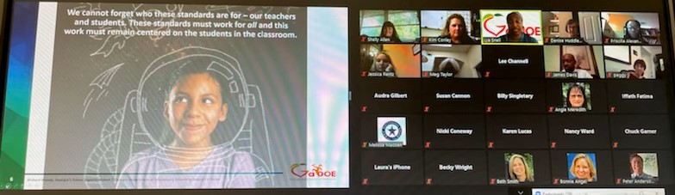
Figure 1 Snapshot from the GCTM August Roundtable.

August Roundtable participants reviewed the grade level/course documents and were able to ask questions about the rational for specific changes and plans for the roll out of the standards over the year.

An overview of the proposed plan for implementation of the NEW GEORGIA MATHEMATICS STANDARDS:
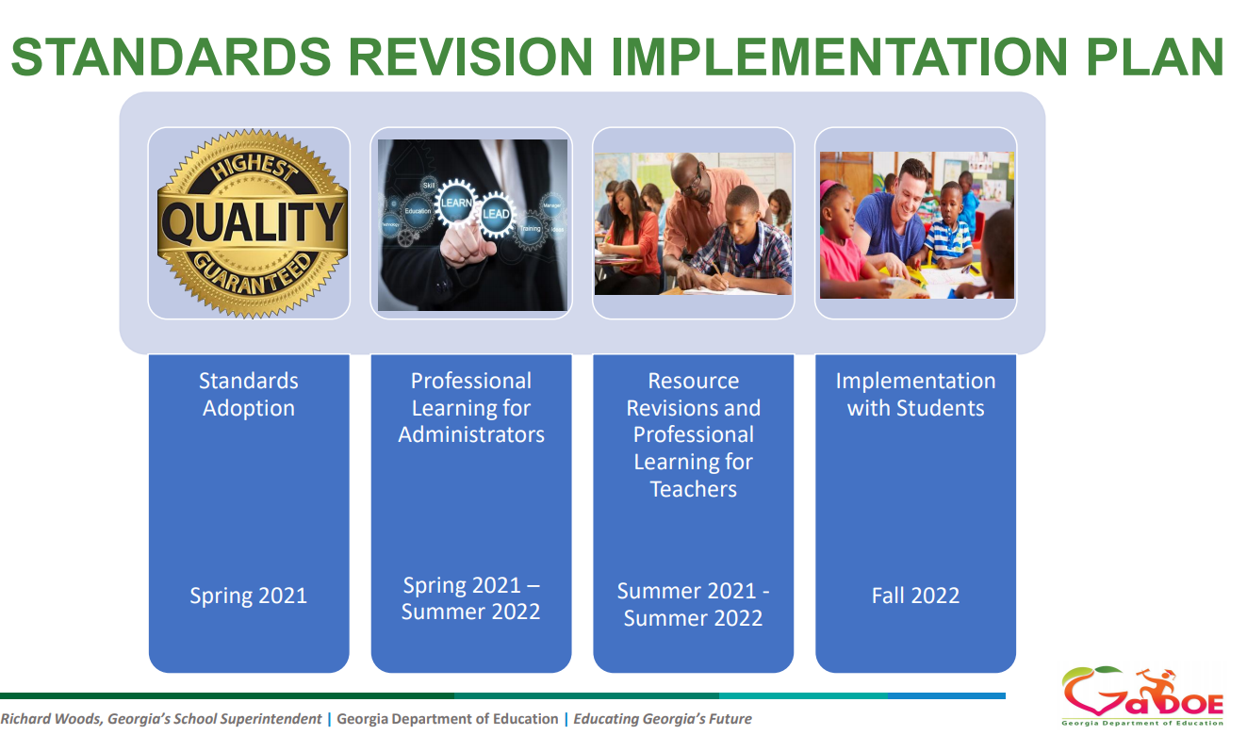

Dr. Snell also provided a summary of some of the professional learning options that can be used during this year www.gadoe.org/mathematics
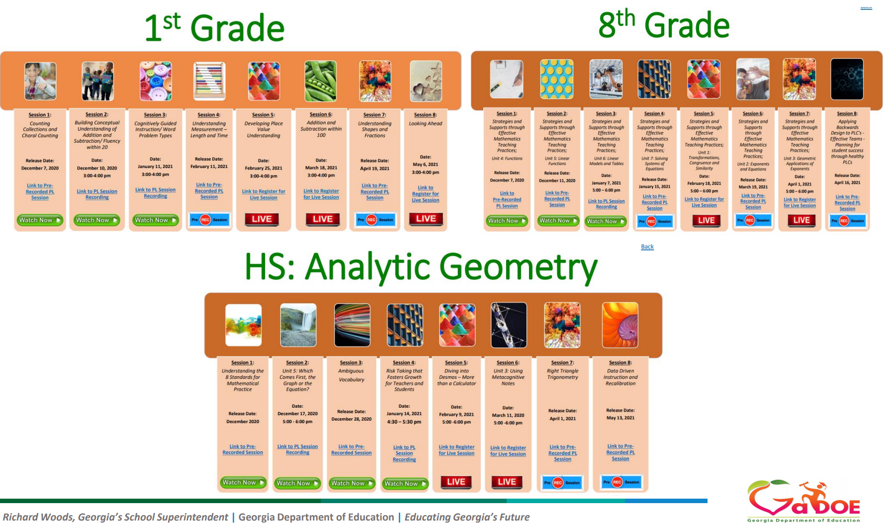

Stay tuned for more opportunities to meet and collaborate with leaders across Georgia as we expand our Roundtable discussions this year!

“Roundtable.” Merriam-Webster.com Dictionary, Merriam-Webster, https://www.merriam-webster.com/dictionary/roundtable. Accessed 14 Aug. 2021.

